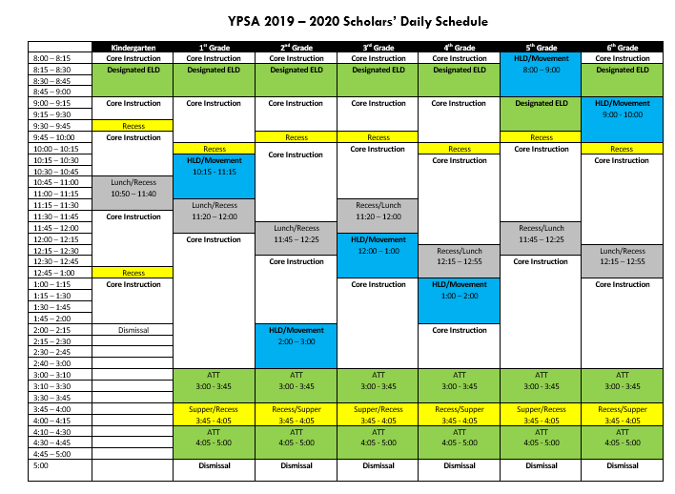

YPSA Daily Scholar Schedule